David Merrick and Garrett Clay

2012-11-15

ECE 375

Lab 7 PreLab

1. Our final project will be an interrupt-driven messaging system using two AVR boards. The boards will communicate with each other over infrared using prewritten messages selected by the buttons. The user will press buttons S1 through S7 to select the desired message on his or her board, this message will display on the LCD screen, then the user will press S8 to send it. Upon receipt of the message, the receiving board will display the message on its LCD screen. Each board will have a unique ID, and each will have the ability to both receive and transmit messages. Each board will only respond to messages sent to its unique ID. The button presses will be driven by polling, but the receipt of messages will be interrupt-driven.
2. Our code will have a MAIN loop that polls the buttons waiting for a press. When a button is pressed, this code will determine which one was pressed, then will branch to a corresponding SELECTMESSAGE state. This will output the message assigned to the pressed button to the LCD screen. It will loop until button S8 is pressed. It will then branch to SENDMESSAGE, which will transmit the bot ID of the receiving bot as well as the message. It will then return to the MAIN loop to wait for a button press. At any point, an interrupt by the receiver will branch the execution to a DISPLAYMESSAGE state, which will output the received message to the LCD screen before returning to the MAIN loop.

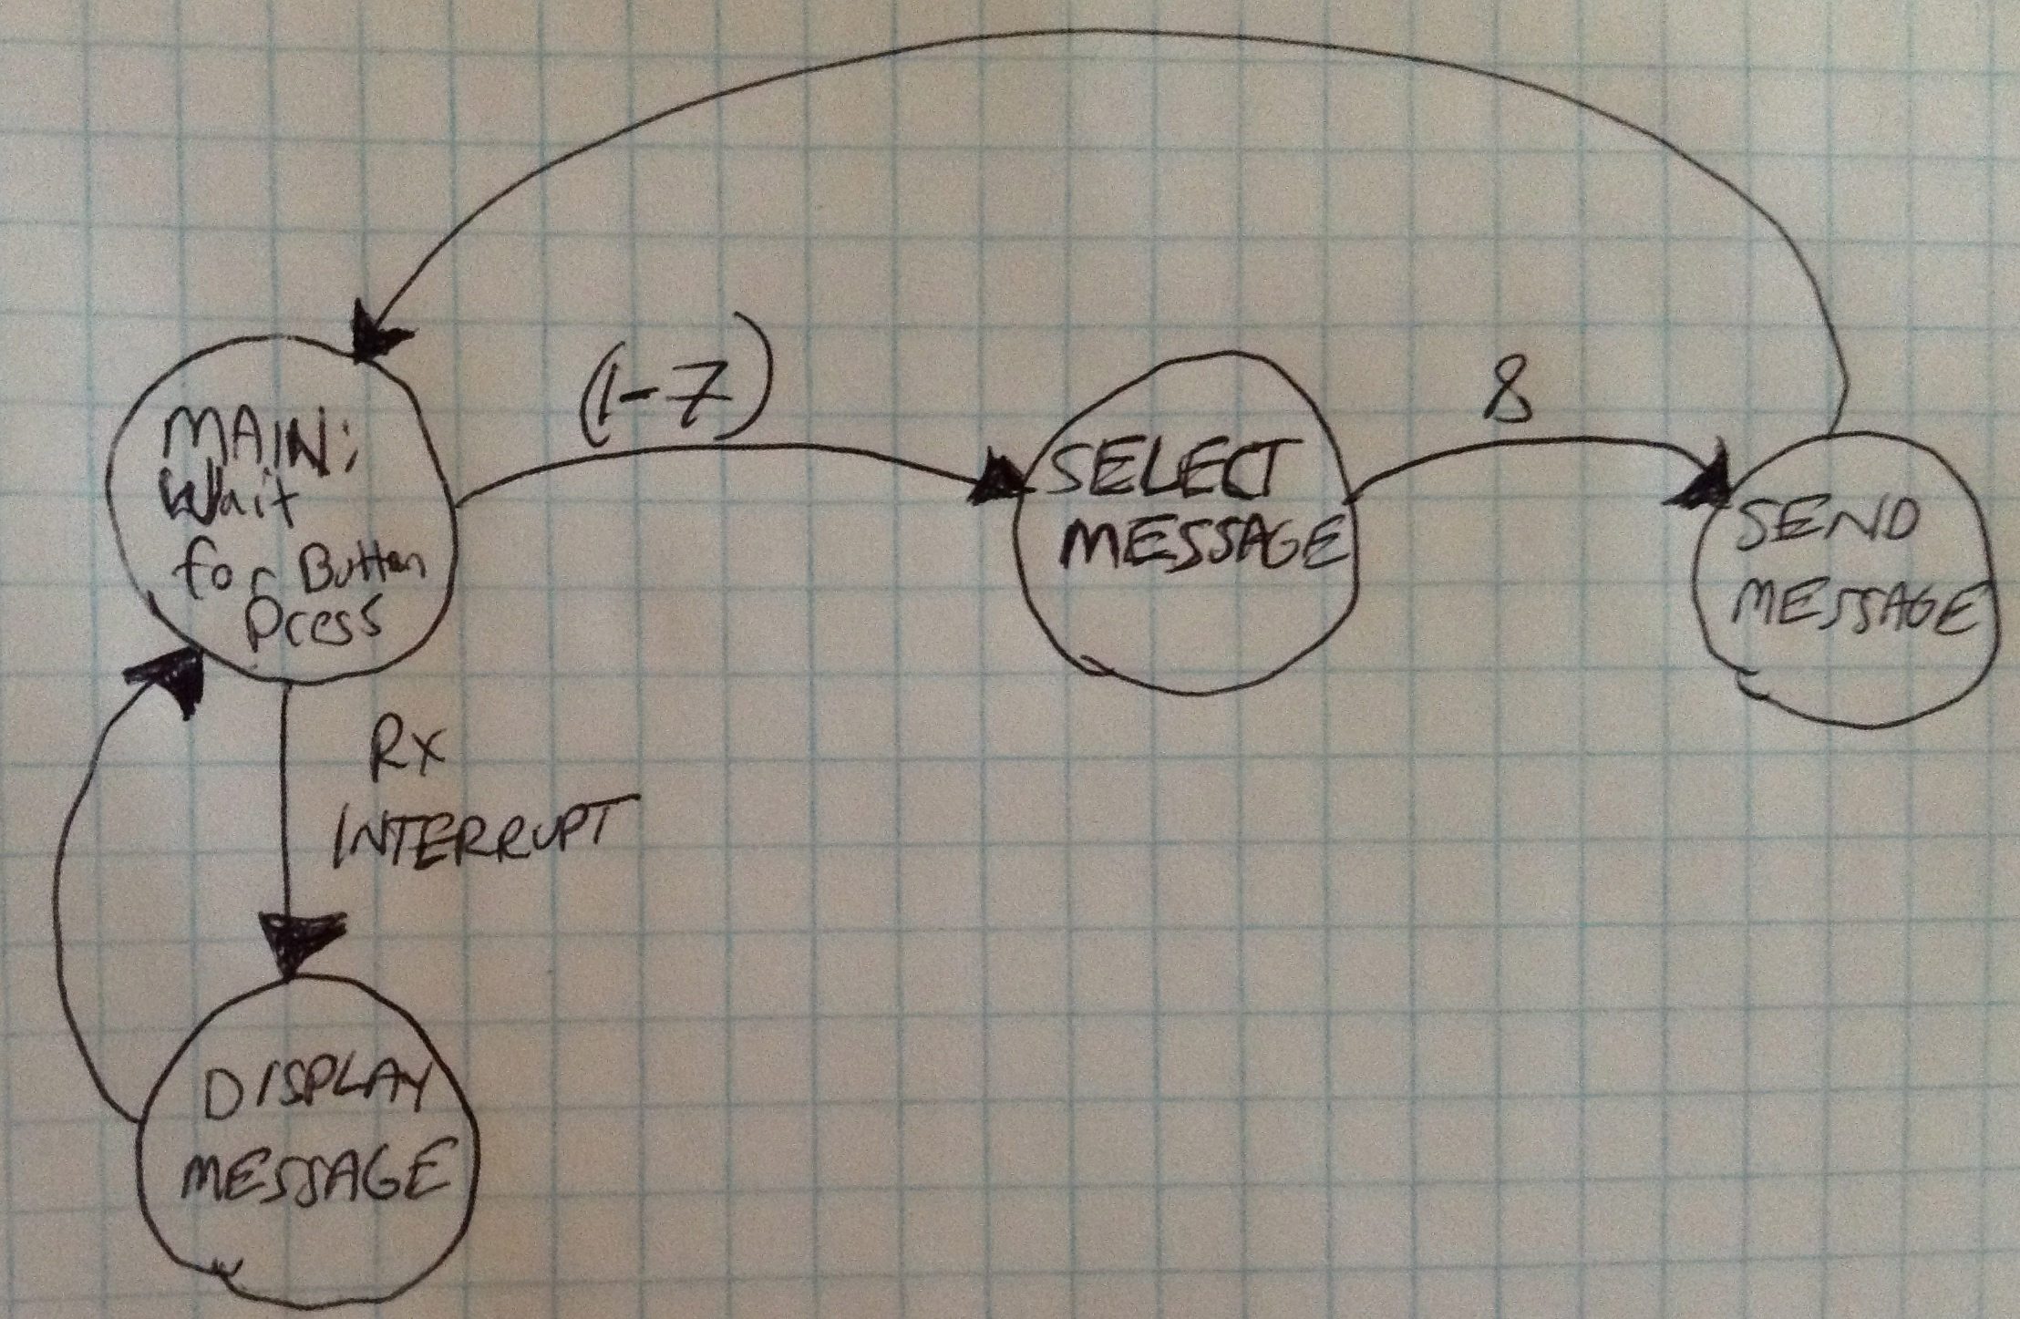

1. MAIN: Poll buttons.
   1. If(Button pressed)
      1. Determine which button pressed.
      2. Branch to SELECTMESSAGE with that button ID.
   2. SELECTMESSAGE
      1. Display message corresponding to button ID on LCD.
      2. Wait for user to press button S8.
      3. If(Button S8 pressed)
         1. Branch to SENDMESSAGE
   3. SENDMESSAGE
      1. Transmit receiving botID.
      2. Transmit message.
      3. Return to MAIN loop.
   4. If(execution interrupted by receiver)
      1. Branch to DISPLAYMESSAGE
   5. DISPLAYMESSAGE:
      1. Output received message on LCD.
      2. Return from interrupt.